

**CMPG313**

**PRACTICAL 3**

**Moloto MM**

**28844815**

**Slide Puzzle Game**

Contents

**The Introduction** 3

**Litrature Study** 3

**Design of the application itself** 3

**Description of mouse press** 5

**Tile/Sprite Movement** 5

**Loading position from textfile** 6

**Win Condtion** 7

**References** 8

# 

# **The Introduction**

I am planning to create a 3x3 board puzzle of scrambled picture tiles that has one missing tile and is randomly set up which is developed with Visual Studio Code from Anaconda Python.

The goal of the puzzle is to place the tiles in order by making sliding the tiles that use the empty tile and to solve the puzzle manually without any artificial intelligence.

The reason why I am creating this game in python is that I wanted to explore more in python and learn a new programming language especially on how to create games in python.

Before running the code please enusre that pyglet is installed. You can type out pip install pyglet on the terminal window. Pyglet allows you to create GUI’s in python.

After this package is installed, you can go ahead and run the program.

# **Litrature Study**

# Trevor Tredoux which is my class mate was my main source through out the whole program. And helped me to get started with the basics like loading an image and calculating the the positions of each image. And How to load a textfile and the movements of the images to slide.

**Preview of the image:** I used a rick and morty image as my preview which I got from the (HDq walls,2018 ) which is also the solution of the game.

Also used a rick image as my background image which I also got from a website called (HDq walls,2018)

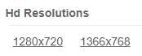

**Cutting of the images:** I used a rick and morty image which I also got from(HDq walls,2018) used this website to also cut the pictures into 9 pieces.

**Installing pyglet**: Trevor and I watched a (youtube) tutorial video on how to install pyglet

**Loading the images:** We used (stackoverflow,2017) to see how to load a image using pyglet

**Movements of sprites using keys:** For movement of sprites we used a website called (python multimedia,2010

**Movements of sprites using mouse press :** I used a webite called (read the docs)

**Displaying labels:** I went through a pdf called ( pyglet programming guide)

**Loading a state from a textfile**: I went though an e-book called (Learning python language)

# **Design of the application itself**

I used pyglet to create the GUI by importing the library import pyglet then created a defualt contstrator that will display a Window

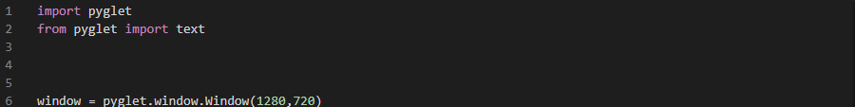

Firstly I intialised all the variables I am going to use through out by setting the forms. I used resolution which is 1280 and 720 p. I used a website called( HDq walls,2018) to cut up my orginal picture into 9 pieces each piece has a witdth of 160 and a height of 120 which I initialiased below.

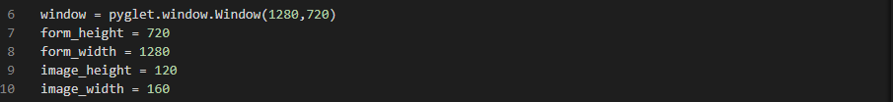



Then I loaded each piece of picture and used sprites which is like a picture box to display the picture and for each picture loaded there is a sprite that includes the pictures location where each picture will be placed when I run my program. Trevor helped me by calculating the location of the images by using the form height, width and image height and width.

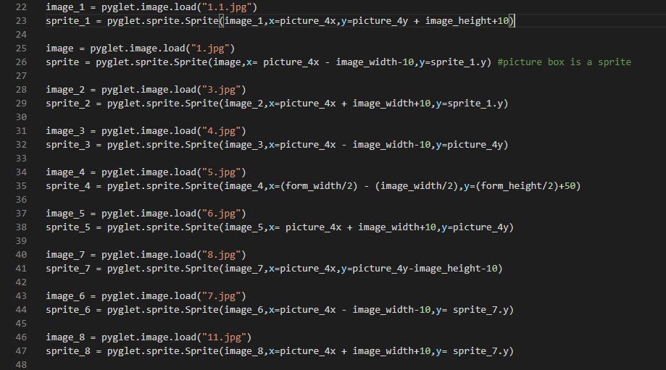

KeyPress Method

Firstly I implemented a on key press movements to check if my images will move using keys because I had no idea on how to implement the on press mouse event. So I just used up ,down,left and right keys to compare the spites movements.

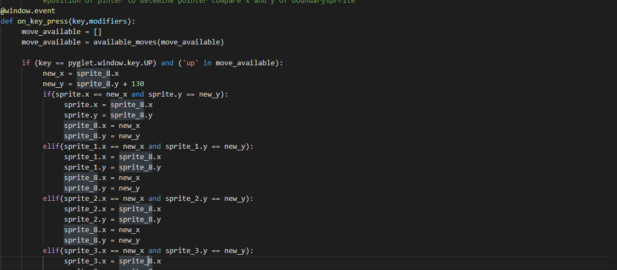

# **Description of mouse press**

Then Trevor helped me to create the on mouse press method with three parameters inside it. This method uses each 9 sprites by using and x and y coordinates. So each sprite has an x value then it will be added with the sprite’s image witdth and y value that will be added with the sprite’s image height to get the exact coordiantes when the user hovers their mouse over the images.

Then to know where to move to an blank tile

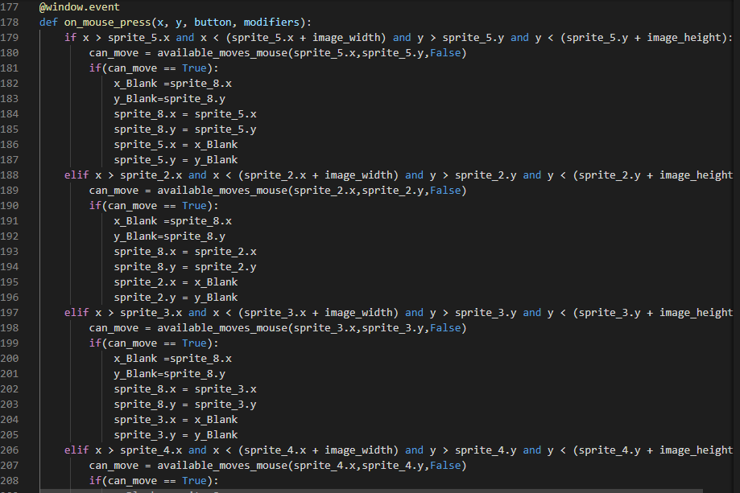

# **Tile/Sprite Movement**

The movement of the images is implemented by creating a method called available movements check and give coordinates of movement it can make. And to check the position of the mouse pointer to determine pointer and compare x and y of boundary sprite. location of empty blocks.

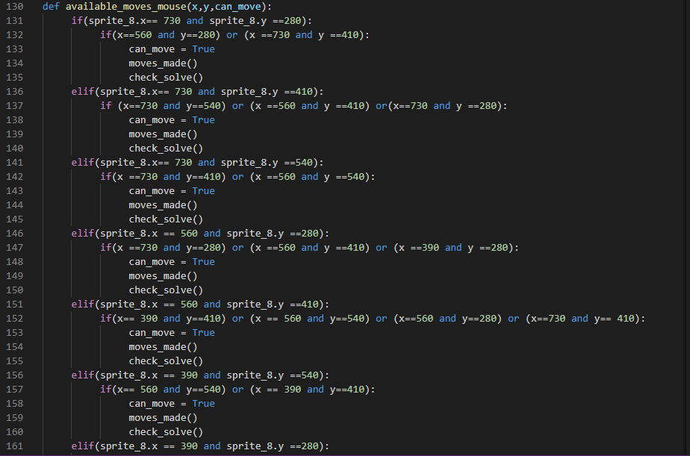

For the moves made method I created a global variable so that it can accces every other method. Then I intialised it to 0 and added 1 so that it can increment every time when a image is moved. Then I called this method in the available moves mouse so that when I click my mouse on the image it will automatically count the moves made

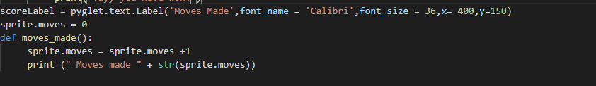

For some reason the moves made does appear on my GUI

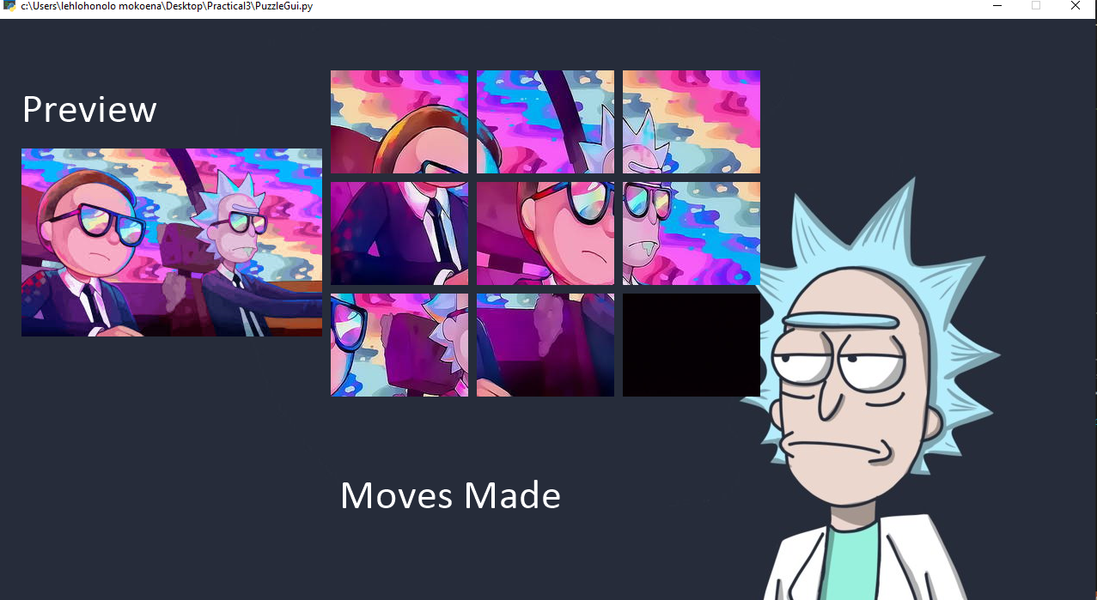

But it does show on my terminal window when using the print statement

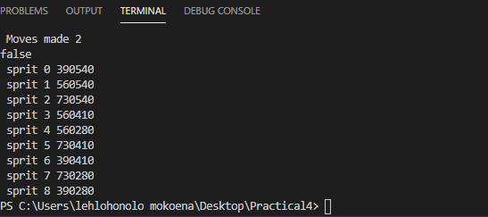

# **Loading position from textfile**

Then I created a text file called intial_state I created this textfile so that when I ran my program the images will be randomly mixed around and I did that by mixing up the coordintes of the images in the textfile.

So when the program rans it will read all the coordinates in the textfile



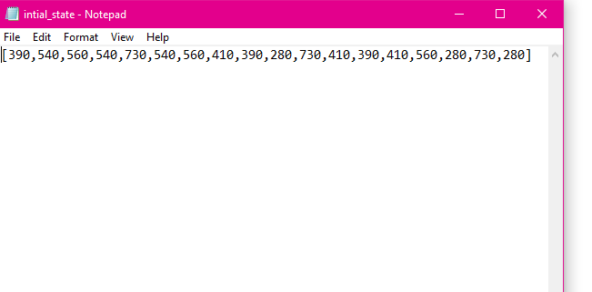

Then I called my intial states by indicating each x and y coordinates

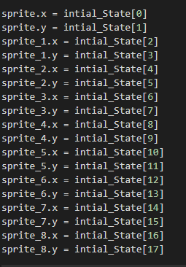

# **Win Condtion**

The check solve method checks if every sprite its in its correct position

We used coordinates to check if every sprite is at its correct position if not then it will print out false then if its at its correct position it will print out yaay you have won

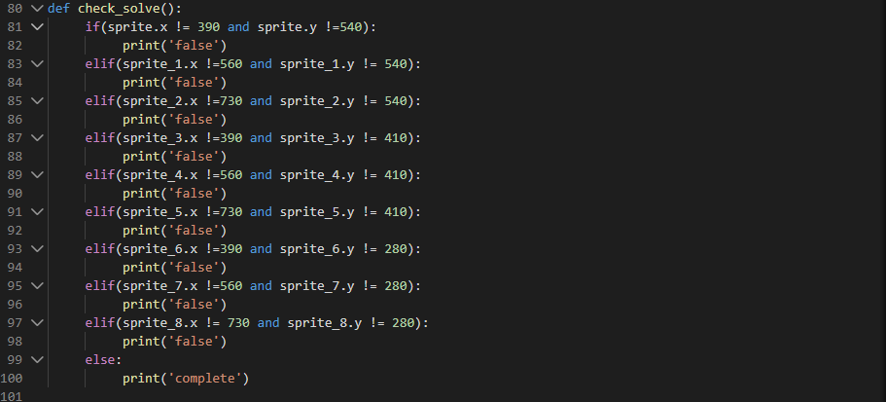

I had dificulties showing it on my GUI but does show on the terminal window

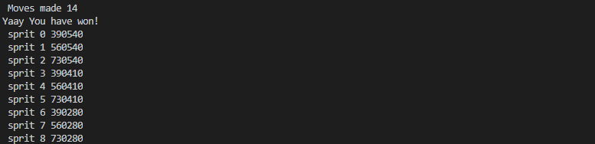

Then the on draw() event is used to draw its contents on to window.Which draws every gui control that is created and it is displayed in the window. The pyglet library provides several ways to attach event handlers to objects.

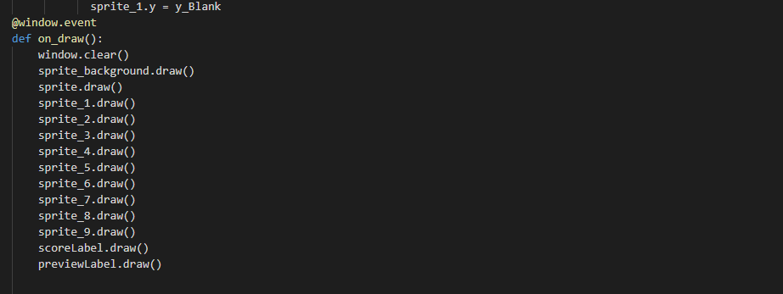

To run the pyglet app I used the following line pyglet.app.run() which is appended at the end of the source code



# **References**

Hdwalls <https://hdqwalls.com/download/1280x720/rick-and-morty-hd> Date of access: 16 May 2020

<https://www.youtube.com/watch?v=lJQ3UgcDHto>

Loading an image. 2015. <https://stackoverflow.com/questions/17508702/loading-an-image-using-pyglet> Date of access: 05 June 2020

Packet,2010. Python multimedia:Animiation Examples using Pyglet.<https://hub.packtpub.com/python-multimedia-animation-examples-using-pyglet/> Date of accces: 19 May 2020

Read the docs. Working with mouse.<https://pyglet.readthedocs.io/en/latest/programming_guide/mouse.html> Date of access: 01 June 2020

Programming Guide.2011. <https://xivilization.net/~marek/binaries/programming_guide.pdf> Date of access: 10 June 2020

Chuahun,A,2013. Geeks for GeeksCheck if possible to move from given coordinate to desired coordinate. <https://www.geeksforgeeks.org/check-possible-move-given-coordinate-desired-coordinate/> Date of access: 07 June 2020